Android setup for SAF Lionportal Application

### --- **Step 1** Set up React Native environment ---

- Follow the instructions <https://reactnative.dev/docs/environment-setup>

- Make sure you refer to React Native CLI Quickstart

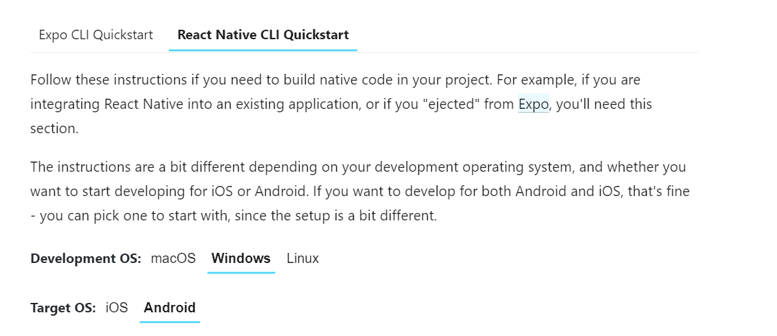

Checklist for the following instructions:

#### Install chocolatey

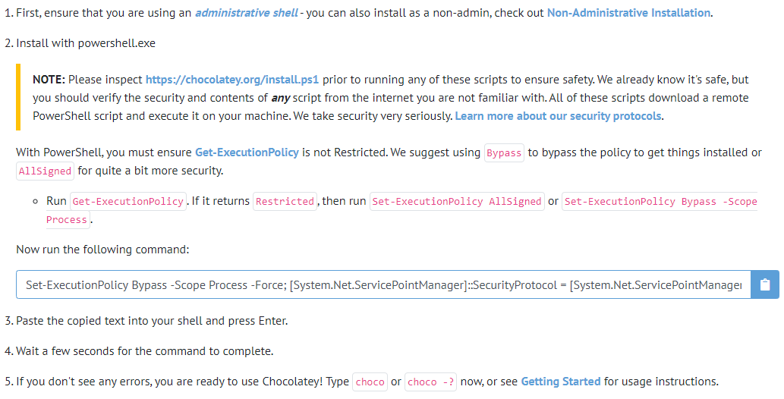

#### Install node.js, python2 and openjdk8 using chocolatey

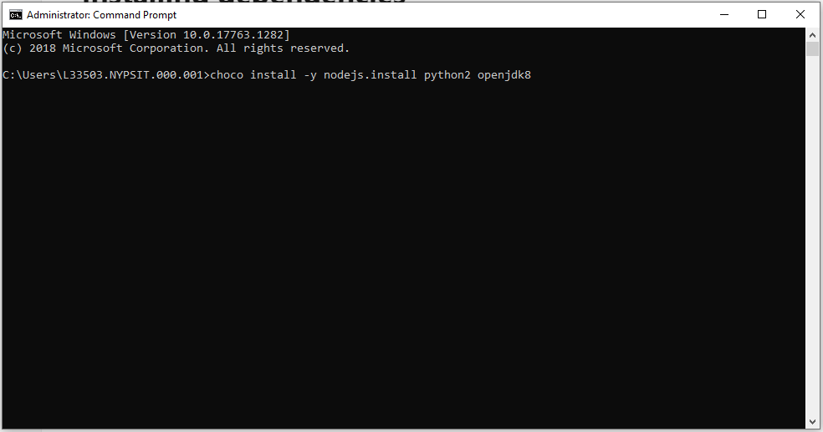

#### Install android studio (School workstation should have android studio installed)

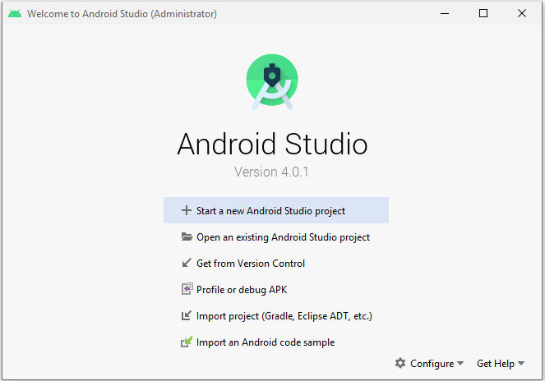

#### Install android SDK

#### Configure ANDROID_HOME environment variable

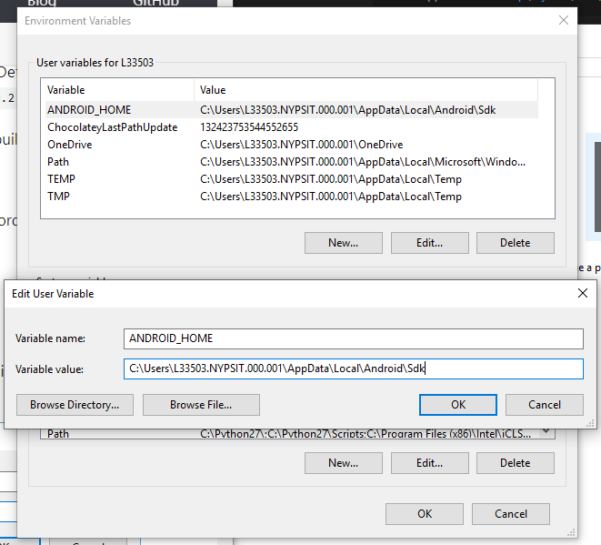

SDK location is "C:\Users\ [Username] \AppData\Local\Android\**Sdk**" for windows.

#### Add platform tools to Path

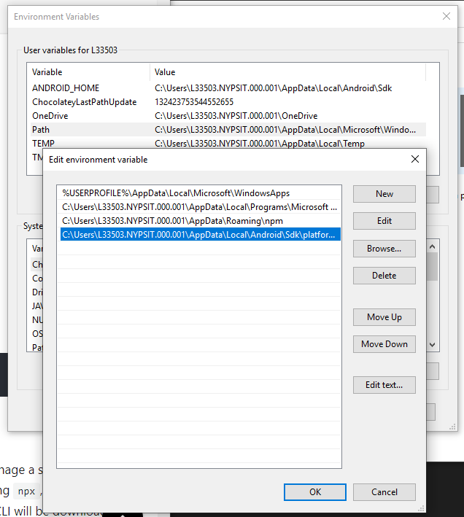

Platform-tools is located "C:\Users\ [Username] \AppData\Local\Android\Sdk\platform-tools" for windows.

1. (Optional) finish the rest of the instructions by creating a new app and running it etc.

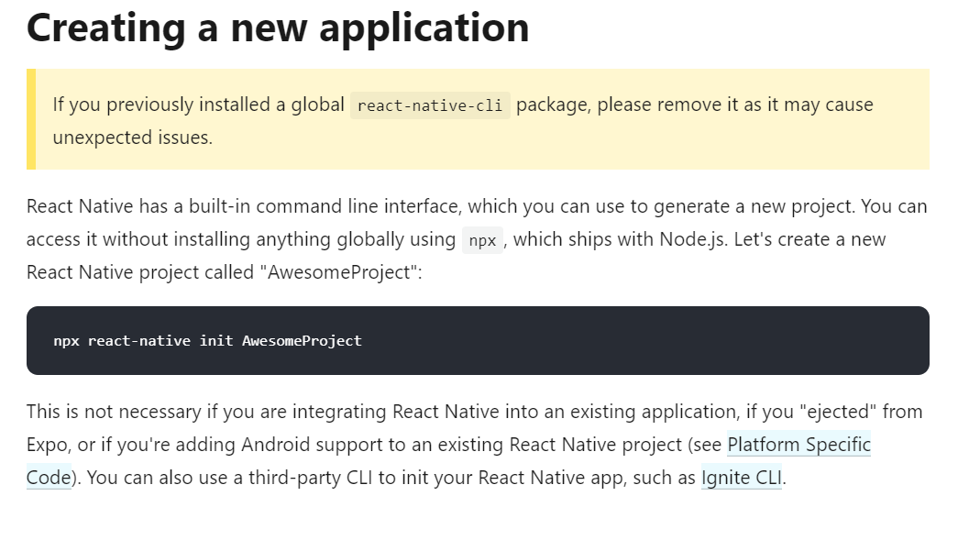

*It is recommended to try this as it is very helpful, especially if you have not done react-native app development before.

### --- **Step 2** Open project in Visual Studio Code (or any other code editor that you prefer)---

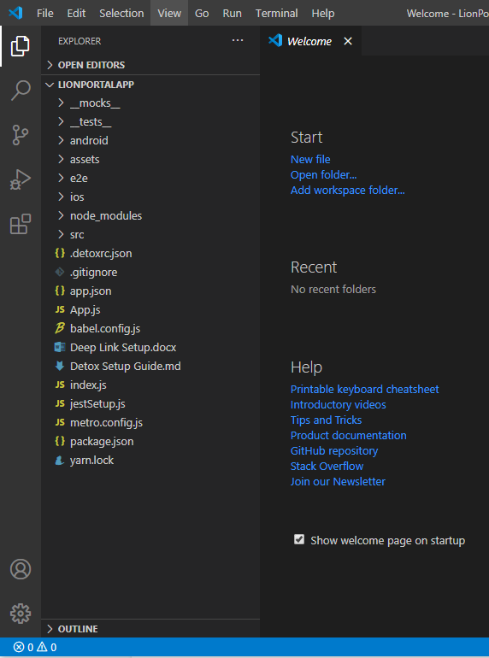

### --- **Step 3** Run ‘npm install’ in the terminal in Visual Studio Code ---

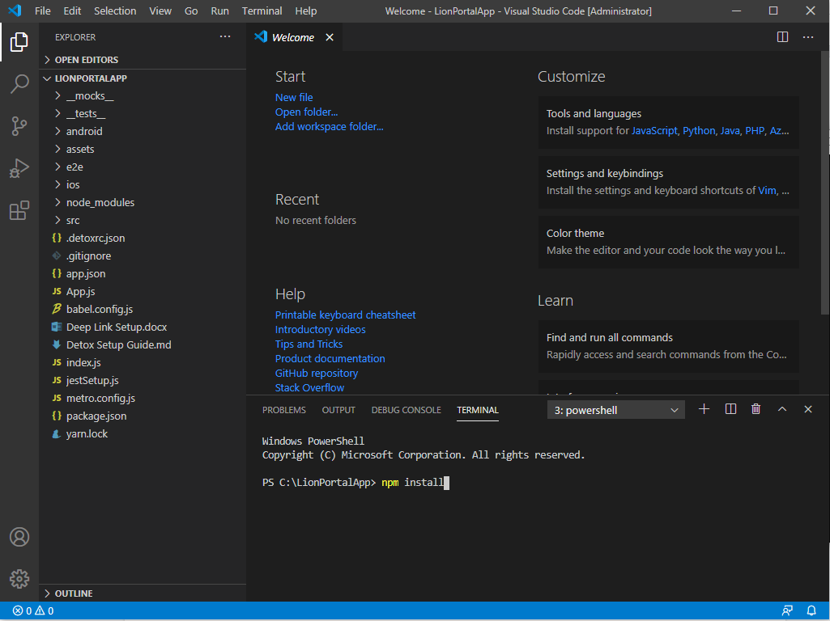

### --- **Step 4** Open and run the app in android studio ---

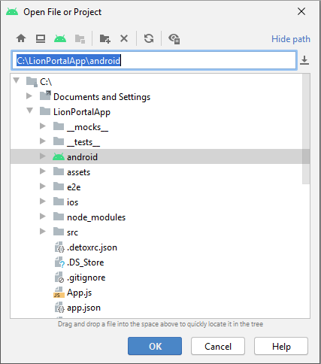

The android folder in the project will have an android icon so it’s hard to miss.

After the android project builds, run the app on the emulator.

### --- **Step 5** Run ‘npx react-native run-android’ in visual studio code ---

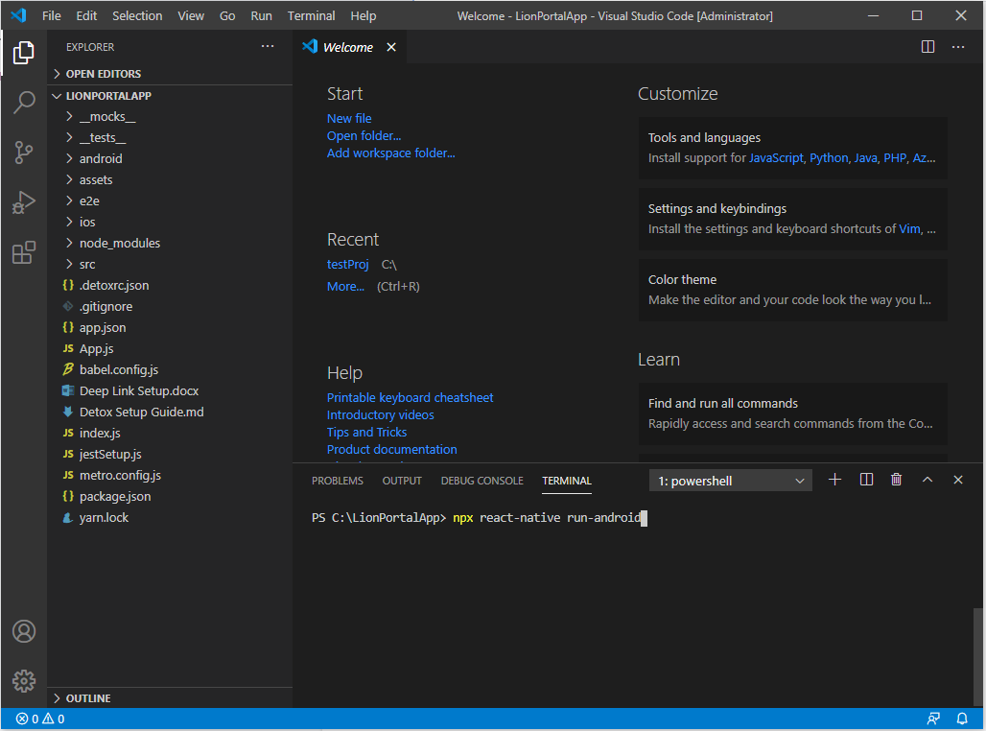

Once the server is running, refresh app running on the emulator.